DEPARTMENT OF ADVANCED SCIENCE AND TECHNOLOGY

UNIVERSITY OF COMPUTER STUDIES, PYAY

2022-2023 Academic Year

Computer Science (Second Year)

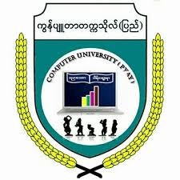

Feasibility Study Report

**“Online Blood Donation Management System’’**

September,2023

PYAY

**“Online Blood Donation Management System’’**

Present by

Ma Hsu Myat Mon Kyaw 2CS-48

Ma Khin Thiri Mon 2CS-40